Capstone Project Phase A

**Classification of ADHD vs. Healthy Children Using Pattern Matching on EEG Signals**

24-1-R-5

Basel Kabia, Mohammed Khatib

Supervisors: Dr. Anat Dahan, Dr. Samah Idrees-Ghazawi

**Table of Contents**

1 Introduction. . . . . . . . . . . . . . . . . . . . . . . . . . . . . . . . . . . 3

2 Analysis of EEG Signals. . . . . . . . . . . . . . . . . . . . . . . . . 4

3 Dataset and Methods Overview. . . . . . . . . . . . . . . . . . . 5

4 Computational Biology and Stringology in EEG Analysis….. 7

4.1 BLAST. . . . . . . . . . . . . . . . . . . . . . . . . . . . . . . . . 8

4.2 AVID . . . . . . . . . . . . . . . . . . . . . . . . . . . . . . . . . . 9

4.3 Order preserving matching. . . . . . . . . . . . . . . . . . 9

5 Requirements (Functional and Non-functional) . . . . . . . . . 11

6 Proposed Research Plan. . . . . . . . . . . . . . . . . . . . . . . . . 12

7 The structures of the methods. . . . . . . . . . . . . . . . . . . . . 13

8 Expected Challenges. . . . . . . . . . . . . . . . . . . . . . . . . . . 14

9 Evaluation Plan. . . . . . . . . . . . . . . . . . . . . . . . . . . . . . . . 14

10 Expected Achievements. . . . . . . . . . . . . . . . . . . . . . . . 16

**Abstract.** Understanding the neurological underpinnings of Attention-Deficit/Hyperactivity Disorder (ADHD) is crucial for advancing diagnosis and treatment. Electroencephalography (EEG) emerges as a promising tool for objective assessment, capturing brain activity patterns indicative of ADHD. By dissecting EEG data into frequency bands corresponding to distinct brain wave oscillations, researchers gain insights into brain function. This research project reviews methodologies leveraging EEG signals to discern ADHD-related patterns, emphasizing pattern matching algorithms from computational biology and stringology. The study explores various methods, including BLAST and order-preserving matching for EEG analysis. Additionally, it details a research plan involving dataset analysis, algorithm development, and unsupervised learning techniques to differentiate ADHD EEG signals from healthy controls.

**Keywords**: Electroencephalography (EEG), Attention-Deficit/Hyperactivity Disorder (ADHD), Pattern matching algorithms, Computational biology, BLAST, Order-preserving matching

**1 Introduction**

The brain's functionality relies on the intricate electrical communication among billions of neurons, generating characteristic electrical rhythms that underpin cognition, emotion, and behavior. Electroencephalography (EEG) serves as a pivotal tool in capturing these electrical signals, utilizing electrodes strategically positioned on the scalp to record neuronal activity. While lacking in spatial resolution to pinpoint individual neuron activity, EEG provides valuable insights into overall brain function and aids in identifying patterns associated with various cognitive processes and neurological disorders [4]. One such disorder is Attention-Deficit/Hyperactivity Disorder (ADHD), characterized by inattention, hyperactivity, and impulsivity. ADHD poses significant challenges to daily functioning and is often diagnosed based on behavioral observations [1]. However, utilizing EEG signals for ADHD diagnosis offers a promising avenue for objective assessment, leveraging contemporary neuroimaging techniques to identify characteristic brain activity patterns associated with the condition. This approach holds potential for improving ADHD detection and management compared to traditional methods, enhancing our understanding and treatment of this prevalent mental health condition [2].

**2 Analysis of EEG Signals**

Current ADHD diagnostic procedures typically involve subjective assessments via consultations with healthcare professionals, behavioral evaluations, and standardized questionnaires, which may lack clarity due to their reliance on subjective observations from parents, teachers, and clinicians. However, recent advancements, such as EEG brain scans, offer a more objective approach to understanding ADHD [3]. EEG signal interpretation relies on various techniques, with frequency analysis playing a pivotal role. By decomposing EEG data into frequency bands corresponding to different brain wave oscillations, researchers can gain insights into underlying brain function. These oscillations, including delta, theta, alpha, beta, and gamma waves, are associated with distinct cognitive activities and brain states, providing valuable information for refining ADHD diagnosis, and understanding brain activity patterns associated with the disorder. Here's a breakdown of the primary frequency bands and their associated brain activities (Figure 1):

* Delta waves (0.5 - 4 Hz): Associated with deep sleep and unconsciousness.
* Theta waves (4 - 8 Hz): Associated with relaxation, meditation, REM sleep, and memory formation.
* Alpha waves (8 - 13 Hz): Observed during wakefulness and relaxation, linked to passive attention and suppression of distractions.
* Beta waves (13 - 30 Hz): Predominant during active focus, concentration, and cognitive tasks.
* Gamma waves (30 - 100 Hz): High-frequency waves associated with higher cognitive functions such as perception and consciousness.

Comprehending these established associations between brain wave frequencies and brain activity is instrumental in investigating various brain states and cognitive processes [5].

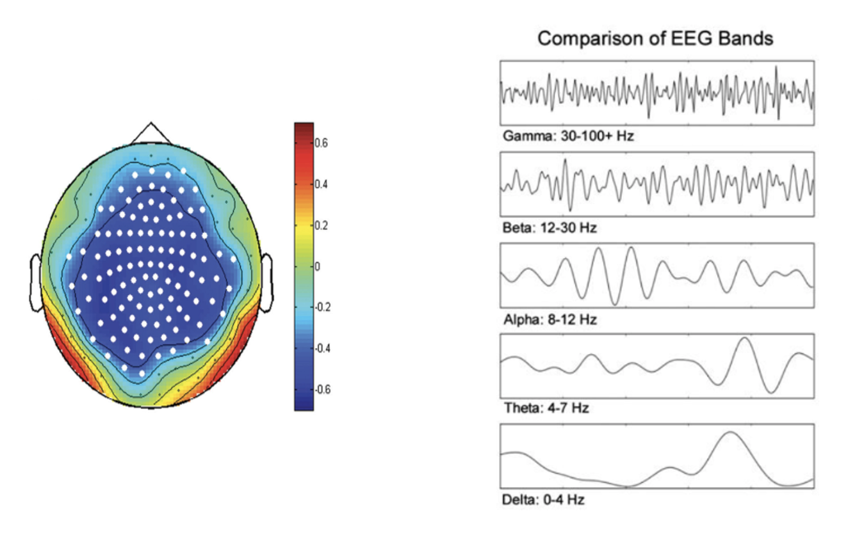

Fig. 1: On the left, there is a topographical map displaying brain activity. The map is color-coded to represent different levels of electrical activity, with a scale ranging from -0.6 to 0.6. On the right, there is a comparison chart titled “Comparison of EEG Bands”. This chart lists five types of brainwaves: Gamma, Beta, Alpha, Theta, and Delta.

**3 Dataset and Methods Overview**

This research study investigated the potential of EEG for identifying abnormalities in children with ADHD. The dataset used in the previous articles are the same as we used in this this study, so we can use them as a reference.

The study involved 61 children diagnosed with ADHD and a control group of 60 healthy participants between the ages of 7 and 12. ADHD diagnoses were established based on the DSM-IV criteria and confirmed by an experienced psychiatrist. Notably, the children within the ADHD group had received Ritalin treatment for a maximum duration of 6 months. The control group participants were screened to ensure no prior history of psychiatric conditions, epilepsy, or high-risk behaviors.

EEG recordings were conducted using a standardized 19-channel configuration adhering to the 10-20 system, with a sampling rate of 128 Hz. Reference electrodes were positioned on the earlobes (A1 and A2).

To specifically examine visual attention deficits in children with ADHD, the EEG recordings were obtained during tasks designed to assess visual attention. The task involved presenting the children with cartoon characters that they were required to count. The number of characters displayed varied randomly between 5 and 16, and the image size was optimized for clear visibility and accurate counting, also the EEG recording duration was dynamically adjusted based on the individual child's response speed.

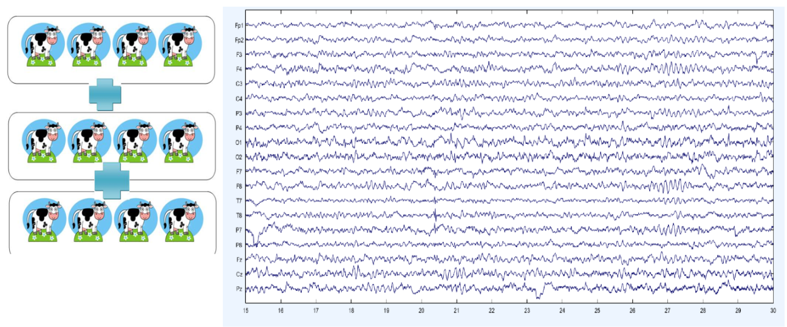

Fig. 2: Frequency of EEG during activity represents the 19 channels.

The following methods represent some of the prominent approaches encountered in our research for analyzing EEG data (using the dataset we have described earlier):

1. **ADHD detection using dynamic connectivity patterns of EEG data and ConvLSTM with attention framework:**

This novel method focuses on the dynamic connectivity patterns between EEG channels across different timeframes. This approach offers the advantage of preserving both spatial and temporal information within the data while simultaneously reducing its overall size. Researchers then leverage a sophisticated neural network model that combines a Convolutional Long Short-Term Memory (ConvLSTM) architecture with an attention mechanism to distinguish between ADHD patients and a control group [6].

1. **TMP19: A Novel Ternary Motif Pattern-Based ADHD Detection Model Using EEG Signals:**

This method presents a hand-crafted classification model inspired by deep learning networks. It utilizes the Tunable Q Wavelet Transform (TQWT) to decompose the EEG signals into wavelet subbands. Subsequently, informative features are extracted from both the raw EEG signals and the wavelet bands using a proposed Ternary Motif Pattern (TMP) and statistical methods. This combination leads to the model's name, TMP19, signifying the incorporation of features from 18 subbands and the original EEG data [7].

1. **Detection of ADHD cases using CNN and classical classifiers of raw EEG:**

This approach involves training a Convolutional Neural Network (CNN) directly on raw EEG data for ADHD diagnosis. Following the training process, feature maps extracted from different layers of the trained CNN are used to train classical classification algorithms such as Support Vector Machine (SVM), Logistic Regression (LR), and Random Forest (RF) [8].

1. **Spectral Dependence:**

This method tackles the problem through spectral analysis, which involves decomposing high-frequency, multivariate time series data into their constituent frequency components. This approach allows researchers to study both linear and non-linear relationships within the data, including contemporaneous and lagged processes. The key steps involve analyzing the spectral characteristics of the provided EEG signals using measures like coherence and partial coherence. The implementation often leverages society-dependent spectral indices provided by software packages like ECOSTASpecDepRef R. This approach allows for the identification of subtle relationships that reveal the spatiotemporal dynamics of the analyzed datasets [9].

1. **Analysis of EEG brain connectivity of children with ADHD using graph theory and directional information transfer Ali Ekhlasi:**

This method utilizes effective connectivity measures and graph theory principles to investigate brain connectivity impairments in ADHD. The study employs EEG signals from children with ADHD and healthy controls to construct weighted directed graphs. Phase Transfer Entropy (PTE) is then used to calculate the connections (edges) between nodes within different frequency bands [10].

**4 Computational Biology and Stringology in EEG Analysis**

Our approach involves harnessing both pattern matching and order-preserving matching algorithms from computational biology to effectively classify EEG signals into ADHD and non-ADHD categories. Pattern matching algorithms offer a powerful tool for identifying distinctive patterns in EEG signals indicative of ADHD, allowing us to discern subtle variations that may signify the presence of ADHD. Simultaneously, order-preserving matching algorithms maintain the sequential order of data points, capturing the inherent temporal dynamics of EEG signals. By leveraging these combined techniques, we can facilitate accurate and robust classification of ADHD.

Computational biology, situated at the intersection of computer science, biology, and big data, provides a framework for understanding biological processes through data analysis, mathematical modeling, and computing simulations [11]. Within this domain, pattern matching stands out as a key methodology for analyzing sequences of tokens to identify specific patterns. Unlike pattern recognition, pattern matching requires exact matches, making it well-suited for distinguishing ADHD-related patterns in EEG signals [12].

In our context, pattern matching facilitates both local and global alignment analyses of EEG data. Local alignment focuses on identifying similarities between specific regions of EEG sequences, enabling the identification of functional domains or motifs relevant to ADHD [14]. On the other hand, global alignment assesses overall similarities across entire EEG sequences, aiding in the comparison of EEG data sets to elucidate broader patterns and relationships associated with ADHD [14].

The differences between global alignment and local alignment:

1. Scope:

* Global similarity considers the overall similarity between two sequences or patterns, taking into account the entire length of the sequences.
* Local similarity focuses on specific regions of similarity within sequences, disregarding non-matching regions.

1. Alignment:

* In global similarity, the goal is to find the best alignment between the entire sequences, allowing for matches, mismatches, gaps, and other modifications across the full length of the sequences.
* In local similarity, the focus is on identifying regions of high similarity within sequences, known as local alignments, which may contain matches, mismatches, and gaps.

1. Purpose:

* Global similarity is commonly used to compare entire sequences, such as entire genomes, proteins, or nucleotide sequences, to infer evolutionary relationships, identify functional similarities, or detect structural homologies.
* Local similarity is useful for identifying specific functional domains, motifs, or conserved regions within sequences, such as protein domains or regulatory elements in DNA [15].

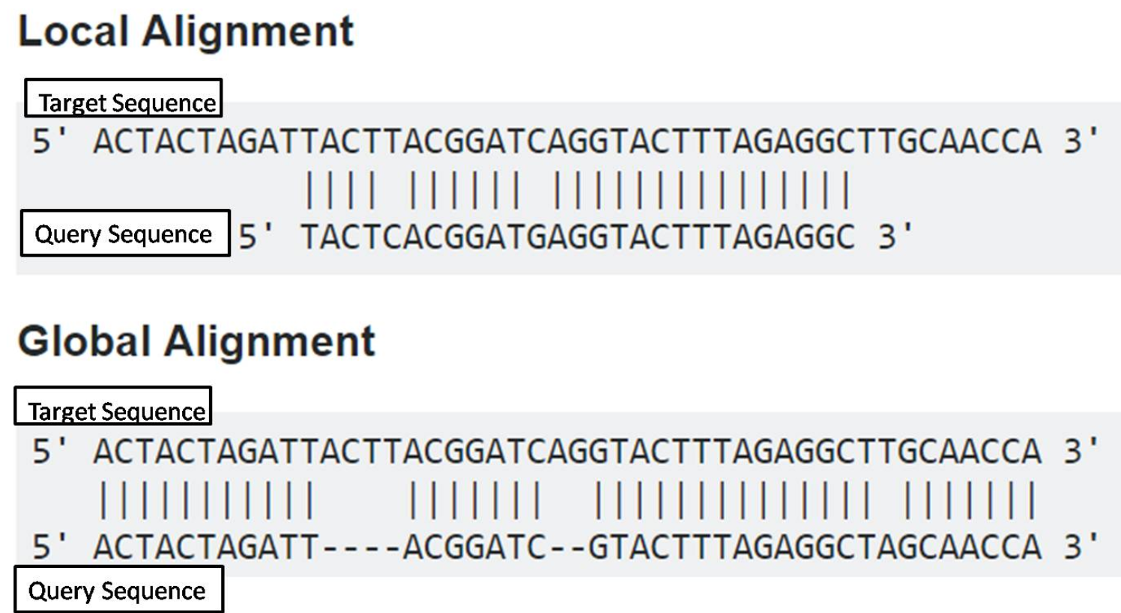

Fig. 3: The image presents a side-by-side comparison of local and global alignment strategies applied to two DNA sequences. In the local alignment section, every base pair matches between the target and query sequence, while in the global alignment section, gaps are introduced to optimize the overall sequence similarity.

Review some methods represent prominent approaches encountered in our research for pattern matching.

**4.1 BLAST**

**BLAST is a novel method being developed to quickly compare protein or DNA sequences. It works by looking only at segment pairs that contain a word pair of length w with a score of at least T. This method is much faster than existing heuristic algorithms and can detect weak but biologically significant sequence similarities.**

While BLAST excels in speed compared to other sequence comparison tools, its efficiency hinges on a specific strategy. It prioritizes examining segment pairs containing high-scoring word pairs of a specific length (w).

This approach translates to faster execution time as the total time required by BLAST is directly proportional to the sum of individual times spent on.

1. **Generating a list of words**: This list encompasses all words within the query sequence that achieve a score of at least T when compared to words in the database.
2. **Scanning the database**: This step involves searching for occurrences(matches) of the high-scoring words from the list within the database.
3. **Extending hits**: Any identified matches are then extended to encompass complete segment pairs, further evaluated based on a pre-defined score threshold.

By limiting its initial search to high-scoring word pairs, BLAST significantly reduces the number of potential matches requiring detailed evaluation. This, in turn, directly translates to reduced execution time and ultimately enhanced efficiency [16].

**4.2 AVID**

AVID is a global alignment program designed to be fast, memory efficient, and practical for sequence alignments of large genomic regions up to megabases long. It can perform these alignments quickly and efficiently due to its use of suffix trees and anchors. These techniques reduce the complexity of the alignment problem, making it feasible to align large genomic regions. Additionally, AVID can use either masked or unmasked sequences, which makes it more flexible than other alignment programs [17].

**4.3 Order preserving matching**

Order-preserving matching, a specialized type of pattern matching, maintains the relative order of elements in sequences or patterns during the matching process. Particularly relevant to bioinformatics tasks like motif identification, order-preserving matching algorithms consider both the presence and order of items, aiding in the discovery of significant biological insights [13].

This article delves into a novel string-matching problem termed order-preserving matching. In this context, a pattern is considered a match within a text if the text contains a subsequence of values that mirrors the relative order of values present in the pattern.

Order-preserving matching finds applications in various domains, such as stock price analysis and musical melody matching. In these scenarios, the relative order of elements holds greater significance than the exact values themselves.

The article further introduces two distinct methods for representing the order relationships within a numeric string:

* Prefix representation: This method captures the ordering information based on the prefixes of the string.
* Nearest neighbor representation: This approach leverages the relative positions of individual elements within the string to represent order relationships.

These representations serve as the foundation for developing efficient algorithms for order-preserving matching. The article details an algorithm with a time complexity of O(n + m log m) for the single pattern case and O(n log m) for the multiple pattern case.

Furthermore, the article provides in-depth explanations of these algorithms, along with a comprehensive analysis of their time complexity. Additionally, it explores potential applications of order-preserving matching in various domains, including financial markets and music analysis.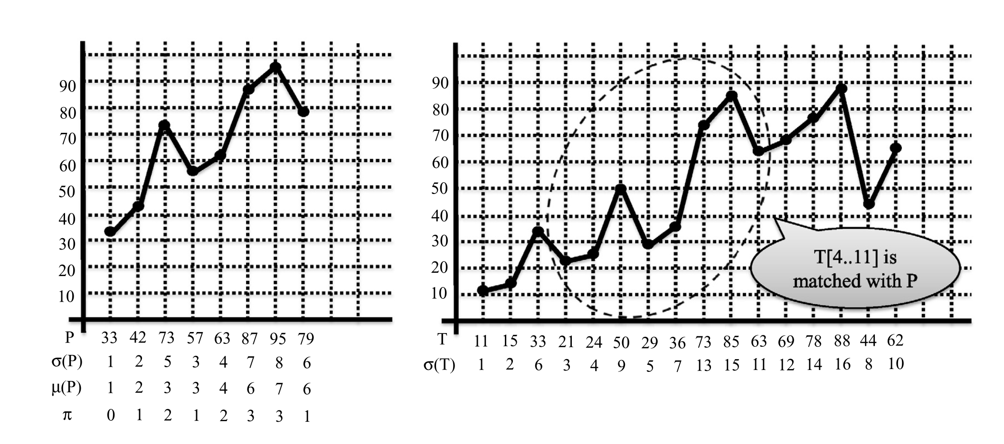

Fig. 4: example of pattern and text:

P= (33,42,73,57,63,87,95,79) is matched with text T since the substring (21,24,50,29,36,73,85,63) in the text has the same relative orders as the pattern. In both strings, the first characters 33 and 21 are the smallest, the second characters 42 and 24 are the second smallest, the third characters 73 and 50 are the 5-th smallest, and so on. If we regard prices of shares, or absolute pitches of musical notes, as numeric characters of the strings, both examples above can be modeled asorder-preserving matching.

**5 Requirements (Functional and Non-functional)**

Our project requires both functional and non-functional elements (Table 1) to effectively analyze EEG data related to ADHD within the frontal brain region.

|  |  |
| --- | --- |
| Functional Requirements | Non-functional Requirements |
| Preprocess EEG signals | Perform efficiently |
| Define subgraphs representing connectivity patterns | Accurately identify patterns |
| Design a BLAST-like algorithm for comparison | Scale with increasing data volume |
| Evaluate similarities | Be user-friendly |
| Visualize results | Have robust security measures |
| Identify differences in brain activity | Handle noisy data effectively |
| Provide insights into ADHD biomarkers | Integrate with existing systems |
| Support personalized diagnosis and treatment strategies | Maintain data privacy |

Table 1: showing both functional and non-functional elements for our project.

The requirements collection process for our project involved a multifaceted approach, utilizing various methods to gather insights from diverse sources. Firstly, an extensive document analysis was conducted, reviewing existing literature and research papers related to EEG data analysis, neuroscience, and ADHD research. This provided a comprehensive understanding of the current state-of-the-art and challenges in the field. Additionally, interviews were conducted with domain expert to gain valuable perspectives on specific requirements, challenges, and expectations for the project. the expert offered insights into ADHD diagnosis, EEG data analysis, and potential methodologies to explore. watch professionals on internet channel in their work environments, such as clinics or research labs, were also undertaken to understand real-world practices and identify specific project requirements. By integrating insights from document analysis, interviews, and observations, a comprehensive understanding of stakeholder needs and constraints was achieved. These insights informed the definition of functional and non-functional requirements for our project, ensuring that the final system effectively addresses the needs of its users.

**6 Proposed Research Plan**

The research process for developing a brain EEG recording analysis system, focusing on adapting Pattern matching and Order preserving matching for analyzing EEG data related to ADHD, begins with an extensive literature review. This involves identifying relevant methodologies, challenges, and advancements in EEG data analysis, graph-based approaches in neuroscience, and ADHD research. Following this, requirement analysis is conducted to define research objectives, hypotheses, and central requirements, considering functional and non-functional aspects, scope, and limitations.

Algorithm development will involve creating and deploying a specialized pattern matching and order-preserving matching system for comparing EEG data between normal and ADHD groups, which is still an idea, and it is not certain that this idea will lead to solving the problem. Experimentation and analysis will utilize the developed algorithm to detect brain activity patterns and functional connectivity networks, while result interpretation and visualization will offer valuable insights into the pathology of ADHD.

In our project we aim to create two methods that can Differentiate between EEG recordings of children with ADHD and EEG of a healthy control group, before using these methods, we plan to use unsupervised learning techniques to enhance the analysis process. Unsupervised learning aids in exploring data structures, extracting relevant features, and preprocessing EEG data by removing noise and artifacts. It also simplifies data representation through dimensionality reduction and enables comparative analysis between ADHD and control groups.

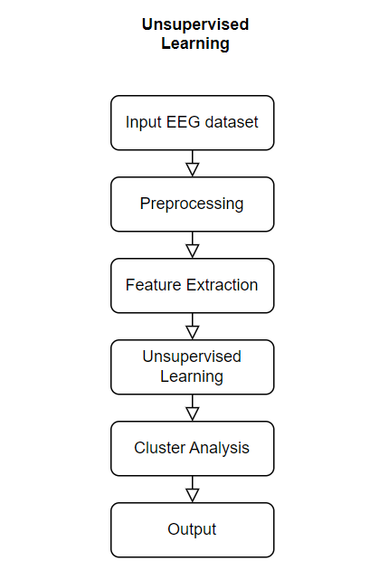

Fig. 5: This flowchart describes the unsupervised learning techniques we aim to use, first, raw EEG data undergoes preprocessing to remove noise and artifacts, then relevant features are extracted from the cleaned data, subsequently unsupervised learning algorithms such as clustering or dimensionality reduction are applied to identify patterns within the data.

**7 The structures of the methods**

First approach we plan to employ the BLAST [16] (Basic Local Alignment Search Tool) algorithm on EEG dataset, the EEG recordings, which capture electrical activity in the brain, will be divided into smaller segments over time. Within each segment, the dominant frequency, representing the prevailing electrical signal, will be identified. These dominant frequencies will then be converted into letters based on a predefined mapping scheme. By mapping the dominant frequencies to letters, we aim to create a sequence representation of the EEG data for each individual. Using BLAST, we will compare these sequences between the normal and ADHD groups to discern any discernible patterns or distinctions in brain activity.

In the second approach, we intend to use an order-preserving matching [17] on raw signal data to comparing sequential data points while maintaining their temporal relationships. The process includes converted data into letters. Alignment algorithms are then used to align corresponding segments between signals, with optimization techniques refining the alignment. The resulting aligned segments are analyzed to identify similarities and dissimilarities, providing insights into temporal patterns.

These methods offer potential avenues for gaining deeper insights into the underlying neurological mechanisms of ADHD. Ultimately, our research endeavors to contribute to the development of innovative diagnostic tools and therapeutic interventions for ADHD based on EEG analysis.

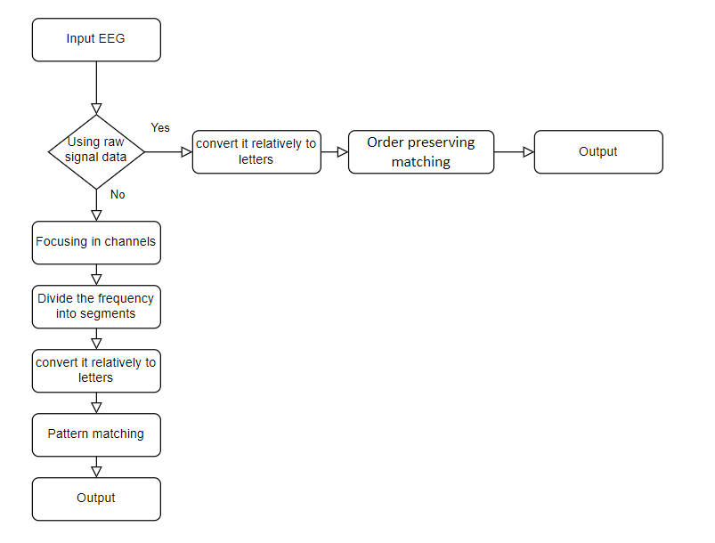

Fig. 6: The flowchart describes the pre-process of achieving the two different approaches.

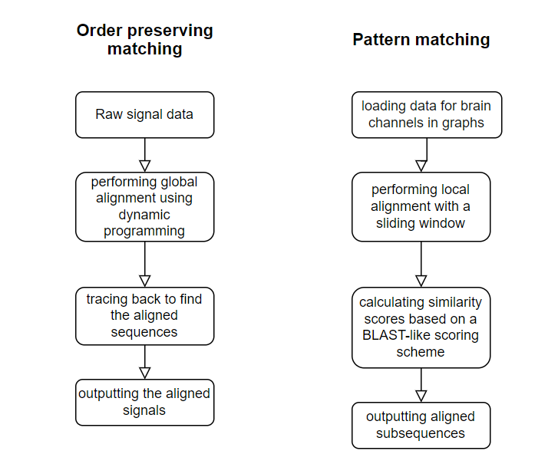

Fig. 7: Flowchart of the two methods.

**8 Expected Challenges**

Anticipated challenges in our project include ensuring high-quality and diverse EEG data, developing Pattern matching and Order preserving matching algorithm, and interpreting results accurately. To address these challenges, a combination of programming languages and libraries, EEG data analysis software, graph analysis tools, statistical analysis software, visualization tools, version control systems, and collaboration platforms will be utilized for data processing, algorithm development, analysis, and collaboration.

**9 Evaluation Plan**

The evaluation plan for this project encompasses several pivotal stages aimed at guaranteeing its reliability and effectiveness. Initially, unit testing will be undertaken on discrete components, including Pattern Matching and Order Preserving Matching algorithms, to verify precise functionality in accordance with predefined test cases (Table 1). Subsequently, integration testing will merge these components to ensure seamless communication and holistic functionality. Data validation will then ascertain the accuracy of input EEG data preprocessing and the mapping of dominant frequencies to letters for the BLAST algorithm. Finally, performance testing will assess computational efficiency and scalability, ensuring the project's suitability for real-world applications.

|  |  |  |  |  |
| --- | --- | --- | --- | --- |
| **Component** | **Test Case** | **Description** | **Expected Result** | **Comparison to Known Labels** |
| **Preprocessing** | Noise Removal | Remove noise from EEG data | Cleaned EEG signals | Compare to known clean signals |
|  | Artifact Removal | Remove artifacts | Artifact-free EEG signals | Validate against artifact-free signals |
| **Feature Extraction** | Frequency Band Decomposition | Decompose into delta, theta, alpha, beta, gamma | Accurate frequency bands | Compare to known frequency ranges |
|  | Dominant Frequency Identification | Identify dominant frequency in segments | Correct dominant frequencies | Validate against known frequencies |
| **Pattern Matching** | BLAST Algorithm | Run BLAST on EEG data | Identified patterns | Compare to known ADHD sequences |
|  | Order-Preserving Matching | Match sequences maintaining order | Aligned sequences | Compare to known ordered patterns |
| **Algorithm Integration** | Component Integration | Integrate all components | Seamless data flow | Ensure output matches expected results |
| **Unsupervised Learning** | Clustering | Apply clustering algorithms | Meaningful clusters | Compare to known group labels |
|  | Dimensionality Reduction | Apply dimensionality reduction | Reduced dimensions | Validate against known reduced feature sets |
| **System Performance** | Computational Efficiency | Test under various data loads | Efficient processing times | Compare to benchmarks |
|  | Scalability | Test handling large data volumes | Scalable performance | Validate against system requirements |
| **Accuracy and Reliability** | Unit Testing | Test individual components | Accurate and reliable results | Compare to known test cases and labels |
|  | Integration Testing | Test combined system functionality | Correct overall system output | Validate against expected results |
|  | Validation with Clinical Data | Use clinical EEG data | Accurate ADHD vs. control differentiation | Compare to clinical diagnoses |
| **User Feedback** | Usability Testing | Gather user feedback | Positive usability feedback | Compare to usability benchmarks |

Table 2: showing Suggested use cases for our program's validation.

**10 Expected Achievements**

The project aims to achieve several key objectives. Firstly, it seeks to provide a new approach to get the accuracy of distinguishing between EEG patterns associated with ADHD and those without the condition, validated through rigorous testing methods. Additionally, it aims to identify distinctive EEG features that could potentially serve as biomarkers for ADHD, validated against clinical diagnoses. The project also aims to deliver a user-friendly system with practical usability metrics, validated through positive user feedback from clinicians and researchers. Ultimately, these achievements collectively aim to provide accurate ADHD identification based on EEG data while offering valuable insights into related brain activity patterns.

Furthermore, we hypothesize that by focusing on relevant/frontal measurement channels, we will achieve better separation between patients and healthy individuals.

**References:**

**[1]** Centers for Disease Control and Prevention. (n.d.). Facts About ADHD. Retrieved from <https://www.cdc.gov/ncbddd/adhd/facts.html>

**[2]** Adamou, M., Fullen, T., & Jones, S. L. (2020). EEG for Diagnosis of Adult ADHD: A Systematic Review With Narrative Analysis. [Frontiers in Psychiatry, 11](https://www.frontiersin.org/journals/psychiatry/articles/10.3389/fpsyt.2020.00871/full)

**[3]** Manos, M. J., & Short, E. J. (2023). A new paradigm for adult ADHD: A focused strategy to monitor treatment. [Cleveland Clinic Journal of Medicine, 90](https://www.ccjm.org/content/90/7/413)

**[4]** Mayo Clinic. (2022). [EEG (electroencephalogram)](https://www.mayoclinic.org/tests-procedures/eeg/about/pac-20393875)

**[5]** Thakor, N. V., & Sherman, D. L. (2012). EEG Signal Processing: Theory and Applications. In Neural Engineering. [SpringerLink](https://link.springer.com/chapter/10.1007/978-1-4614-5227-0_5).

**[6]** Bakhtyari, M., & Mirzaei, S. (2022). ADHD detection using dynamic connectivity patterns of EEG data and ConvLSTM with attention framework. *Biomedical Signal Processing and Control*, *76*, 103708 : <https://doi.org/10.1016/j.bspc.2022.103708>

**[7]** Barua, P. D., Dogan, S., Baygin, M., Tuncer, T., Palmer, E. E., Ciaccio, E. J., & Acharya, U. R. (2022). TMP19: A Novel Ternary Motif Pattern-Based ADHD Detection Model Using EEG Signals. *Diagnostics*, *12*(10), 2544. <https://doi.org/10.3390/diagnostics12102544>

**[8]** TaghiBeyglou, B., Shahbazi, A., Bagheri, F., Akbarian, S., & Jahed, M. (2022). Detection of ADHD cases using CNN and classical classifiers of raw EEG. *Computer Methods and Programs in Biomedicine Update*, *2*, 100080. <https://doi.org/10.1016/j.cmpbup.2022.100080>

**[9]** Ombao, H., & Pinto, M. (2022). Spectral dependence. *Econometrics and Statistics*. <https://doi.org/10.1016/j.ecosta.2022.10.005>

**[10]** Ekhlasi, A., Nasrabadi, A. M., & Mohammadi, M. (2023). Analysis of EEG brain connectivity of children with ADHD using graph theory and directional information transfer. *Biomedical Engineering/Biomedizinische Technik*, *68*(2), 133-146. <https://doi.org/10.1515/bmt-2022-0100>

**[11]** Computational Biology. Retrieved from: <https://en.wikipedia.org/wiki/Computational_biology>

<https://cbd.cmu.edu/about-us/what-is-computational-biology.html>

**[12]** Pattern Matching. Retrieved from:

<https://en.wikipedia.org/wiki/Pattern_matching>

**[13]** Kim, J., Eades, P., Fleischer, R., Hong, S. H., Iliopoulos, C. S., Park, K., ... & Tokuyama, T. (2014). Order-preserving matching. *Theoretical Computer Science*, *525*, 68-79. <https://www.sciencedirect.com/science/article/pii/S0304397513007585>

**[14]** Exploring Local and Global Multiple Sequence Alignment Methods and Their Applications [SpringerLink](https://microbenotes.com/local-global-multiple-sequence-alignment/)

**[15]** differences between global alignment and local alignment. Received from:

<https://www.majordifferences.com/2016/05/difference-between-global-and-local.html>

**[16]** Altschul, S. F., Gish, W., Miller, W., Myers, E. W., & Lipman, D. J. (1990). Basic local alignment search tool. Journal of molecular biology, 215(3), 403-410. <https://www.sciencedirect.com/science/article/abs/pii/S0022283605803602>

**[17]** Bray, N., Dubchak, I., & Pachter, L. (2003). AVID: A global alignment program. Genome research, 13(1), 97-102